**OVERVIEW OF TOTAL INTRAVENOUS**

**ANESTHESIA (TIVA) FOR CHILDREN**

**Pharmacokinetics of Intravenous anaesthetic**

Three compartment model

* Three compartments model is most commonly used to describe the pharmacokinetics (PK) of intravenous anaesthetic
* After an IV drug bolus, the plasma concentration follows an exponential decline in 3 distinct phases, with an initial rapid drop, and the decrease slows and finally a steady and stable decrease.
* This observation can be explained by distribution of drug between a central and 2 peripheral compartments.
* The speed of movement of drug between compartments can be described by equilibration constant between the compartments
* The central compartment is the compartment that connect to the effect site and it is where the drug is metabolize and eliminated. It connected to the other two peripheral compartments which has no direct connection with the effect site.

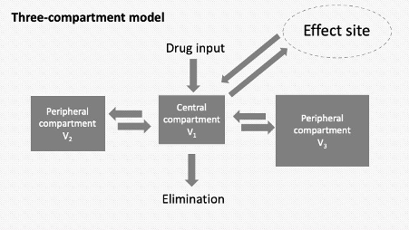

[Figure 3 compartment model](https://1drv.ms/u/s!AnYMFfjlajqeqgPtgzZ1ioQByvyj?e=BlgX8n)

The movement of drugs between compartment can also be illustrated by the 3 compartment "hydraulic" model which is an easier way to conceptualize the movement of drug between compartments.

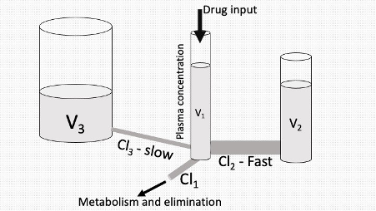

[Figure H Model](https://1drv.ms/u/s!AnYMFfjlajqeqgJfq4U-OieHWVb_?e=af1Cxq)

* The clinical effect of an iv anaesthetic relies on the action of the drug on the receptor of the bio-phase, the brain (effect site)
* The drug's effect (brain concentration) depends on the concentration in the central compartment (V1).
* The other compartment acts as a reservoir with movement backwards and forwards that can be described by mathematical equations.

Context-sensitive half-time (CSHT)

* The time for the plasma concentration (and effect site concentration) to decrease by 50% after an infusion designed to maintain a constant plasma concentration.
* The context relates to the duration of infusion for a drug fitting a multi-compartment model
* CSHT almost always increases with time
* Redistribution to peripheral compartment contribute to the initial drop of central compartment concentration
* As peripheral compartments become full (saturated), the cessation of drug effect will depend on metabolism and elimination from the central compartment

Effect site and Ke0

* It is observed that there is always a delay in effect after an effective drug concentration in the central compartment is achieved. An effect compartment can be constructed and a blood-effect equilibrate constant, Ke0, can be used to describe the delay in clinical effect.
* The effect compartment has an infinitely small volume so it have no influence on the PK model. It is construct to describe the delay in drug onset
* The time lag and the Ke0 can be estimated from measurement of clinical effects, namely EEG or auditory evoked potential
* The Ke0 indicates the speed at which the effect will be obtained. The smaller the Keo the longer the time lag between equilibirium is achieved between the plasma and effect site compartment
* Ke0 is critical in effect site targeting which will be explained later in this week
* The Ke0 is drug specific and also model specific, each drug and the PK models used to describe the PK of a drug has its own ke0. Moreover, ke0 may also vary between patients.

Total intravenous anaesthesia with propofol

* Propofol is a short acting intravenous anaesthetic. With its favourable phamacokinetic it is a suitable agent for induction and maintenance of anaesthesia
* Propofol is also drug with narrow therapeutic index, underdosing is associated with patient movement or awakening, and overdosing associate with depressed respiration state or haemodynamic disturbances
* Induction and maintenance of anaesthesia with propofol relies on continuous infusion and titration to maintain an appropriate plasma level of propofol.
* In adults, the plasma level (Cp) of propofol associated with sedation ranges from 1-3 ug/ml, and the Cp propofol for anaesthesia is around 2.5 - 5 ug/ml.
* Nevertheless there is large interindividual variability in propofol requirement, and the propofol dose required would also depend on the procedure and adjuncts used.
* Titration is the key in delivery of intravenous anaesthesia

Manual Infusion

* Maintaining an appropriate plasma level of propofol may be achieved by manual infusion
* Time variant system because the response to the same input varies with time
* Induction and maintenance of anaesthesia with propofol Involved a loading dose followed by infusion
* Adjust infusion throughout anaesthesia and titrate to the depth of anaesthesia required
* When deepening of anaesthesia is required, a bolus dose with transient increase in infusion rate is often needed in order to raise the Cp to the desired level
* Delivery of propofol by manual infusion is more difficult and complicated, probably less accurate and less suitable for drugs with narrow therapeutic range

Target controlled infusion - TCI

* Equivalent device to a calibrated vaporizer
* Time invariant system – the response to a change of target will be the same irrespective of time at which the target is changed
* TCI system is computer pre-programmed with pharmacokinetic data for a patient population
* The system determine the dose required to achieve and maintain a given blood of effects site concentration by carrying out complex calculation
* Whereas the anaesthesiologist focus on the expected effect of the drug and the timing of the effect
* Improved accuracy and more intuitive to use

Developing TCI models

1. Two stage approach (traditional non-population methods)

* Small numbers of subjects intensively studied
* Sequential sample collection following bolus or infusion and construct poly-exponential curve fitted to drug concentration vs. time
* Derived parameters from a group of subjects averaged to create simple estimates of mean parameter values in that population
* TCI systems works the reverse way by using the PK model to calculate drug dose
* Examples are Marsh, Schnider, Paedfusor, and Kataria Models for propofol and Minto model for Remifentanil

2. Population pharmacokinetic methods

* Larger number of subjects
* Separately estimates fixed and random components
* Data is analyzed as a population but retain their individual identity
* Incorporate parameters that influence PK, e.g weight, age, sex
* Example include Eleveld Model

3. Open TCI system

* Smart pumps incorporates drug library with various PK infusion protocol
* These systems allow non-tagged syringes containing generic propofol to be used

Blood vs. Effect-site control

* The increase in effect-site concentration lags behind the plasma concentration
* To avoid time delay due to effect-site equilibration, TCI systems have been modified to achieve a particular target concentration in the effect site
* This is achieved by raising the plasma concentration beyond the intended effect-site concentration in order to raise the gradient between plasma and effect-site action of propofol

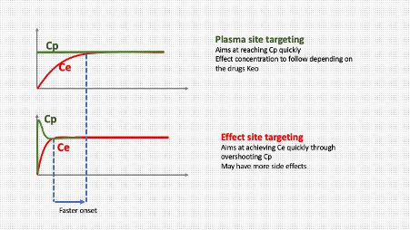

[Figure Cp vs Ce control](https://1drv.ms/u/s!AnYMFfjlajqeqgSp9z4NiFgUERjA?e=QX8fbx)

Caveats

* PK models can only predict the concentration achieved in plasma and effect site. Your patient's pharmacokinetics and pharmacodynamics may vary from the model. Carful titration and monitoring is required.

Impact of Ke0

* Ke0 is a rate constant that describe the time lag between Cp and Ce
* Larger Ke0 = Shorter time lag
* As a result model with smaller Keo results in larger bolus to achieve the same Ce when compare to same model using larger Ke0
* Marsh model is one of the most common model used in TCI system, the new TCI system using Marsh model incorporate a larger Ke0 so as to reduce the impact of a large bolus dose at induction
* It is difficult to know the "right" Ke0 – it is model specific with interindividual difference.
* The following graphs reveal the different of a small and large Ke0 TCI system on effect site target at induction.

Caveats

* If you are confused with Ke0, don't worry! When we talk about the TCI models and dosing, we will give you more guidance on models and technique. If you have a clue about Ke0, this parameter should be considered when predicting loss and recovery of consciousness based on effect site concentration.

*Useful reference on this topic:*

[*https://associationofanaesthetists-publications.onlinelibrary.wiley.com/doi/10.1111/anae.12419*](https://associationofanaesthetists-publications.onlinelibrary.wiley.com/doi/10.1111/anae.12419)[*https://associationofanaesthetists-publications.onlinelibrary.wiley.com/doi/full/10.1111/anae.14355*](https://associationofanaesthetists-publications.onlinelibrary.wiley.com/doi/full/10.1111/anae.14355)

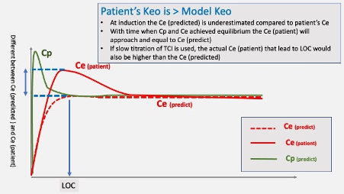

[Figure Small Keo](https://1drv.ms/u/s!AnYMFfjlajqeqge1aQTc-P5Tcu6q?e=ut6t7w)

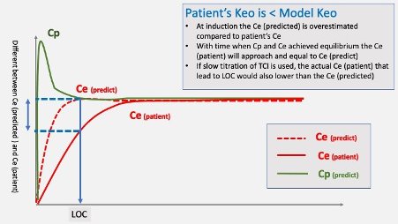

[Figure Large Keo](https://1drv.ms/u/s!AnYMFfjlajqeqgVFsObXYQLUDQeh?e=pfofLV)

**Which TCI model should I use?**

## Limitations of Any Models

* Most pharmacokinetic models were developed in small group of young, healthy, non-obese subjects
* Large inter-individual and intra-individual differences
* Plasma drug concentrations in any individual patients are unlikely to be identical to those predicted by the pharmacokinetic model
* Even less accurate in patients with characteristics deviating from healthy young adult, these include patients with co-morbidities, older patients, obese patients
* Less accurate in extreme clinical conditions including patients in ICU, patients with considerable blood loss, severe hypothermia or metabolic disturbances
* The system take no consideration of drug interaction and concurrent drug therapy

## Why bother about using TCI if it is not accurate?

* TCI pumps can be a useful tool for titrating a propofol infusion to effect (clinical effect or the desired effect on the EEG as measured by a pEEG monitor)
* The reliance on the accuracy of proportional changes to allow titration of the drug concentration to the clinical effects in individual patients is more important than the predicted or measured values
* TCI system also allows determination of a relevant and effective decrement time so as to predict the offset of the drug

## 

## Marsh Model

* Simple model which stood the test of time
* Adapted from the Gepts three-compartmental model developed from a study involving 18 patients receiving propofol infusion
* Used dataset of 150 patients and further validated in 30 patients
* Body weight is the only co-variate in this model
* Central compartment is weight proportional and expressed as ml per kg
* Fixed values for 5 transfer rate constants
* Initially used in DiprifusorTM and currently commonly available in most TCI devices
* Keo was not included in the initial development of this model
* Different researchers attempted to derive a Keo value for this model
* The original keo used was 0.26 min-1
* The new TCI machines used the larger (faster) keo 1.2 min-1 and the newer PKPD model is also called the modified Marsh model

Schnider Model

* More complex model and developed during combined PK-PD studies
* Based on arterial sample from 24 volunteers using bolus and infusion of propofol
* Co-variates include patient weight, height, age, sex and lean body mass
* V1 and V3 (and thus k13 and k31) are fixed, whereas the size of V2 (and thus k12 and k21) is influenced only by age, being smaller with advancing age.
* Limitations of the model
  + Fixed central compartment volume of distribution, meaning the initial bolus will be the same for patient of all body weight and age
  + After a bolus of a given size, the same predicted peak plasma concentration is achieved for all patients
  + As BMI increases beyond 42 kg m-2 in males, and 37 kg m-2 in females, there would be a paradoxically low calculated LBM causes a large increase in calculated k10. TCI systems implemented different solution to handle this.
* To achieve the same plasma concentration, the dose administered considerably smaller than those from Marsh

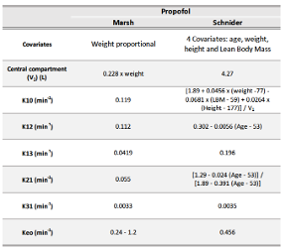

Eleveld Model

* This is a “general purpose model” with allometric scaling. Developed for a broad population range: adults, children, older subjects, and obese adults
* It is an important advance as this model incorporates PK data derived from 30 previously published studies containing data collected from children of all ages, adults, obese adults and elderly individuals (no more choice such as Marsh v Schnider, different model for kids etc.)
* Constructed a 3-compartment model where weight, age, sex and administration of comedication were covariates
* Retrospective analysis of this model performance shows that the model performs at least as good as, or better, than dedicated population models in all populations
* The model showed a bias < ±20% in children, adults, and obese adults, but a greater bias (−27%) in older subjects. Precision was < 30% in all groups. For PD, the bias and wobble were < 5 BIS units and the precision was close to 10 BIS units in all groups

Paedfusor Model

* Model developed in 29 children undergoing cardiac surgery
* Allowance for steady increase in clearance in younger children
* Lowest age 1 year
* Lowest weight 5kg
* Covariate: weight
* reported to have a median performance error (MDPE) bias of 4.1% and a median absolute performance error (MDAPE) precision of 9.7% over the age range investigated (1 -15 years)

Kataria Model

* Developed in 53 children
* 3-11 yo
* BW 15 – 61 kg
* Commonly used and appropriate for the age range described
* Below 12.5kg and age 2 year the 2nd comaprtment become negative
* Covariates: weight and Age

Which model should I use?

* Common teaching is to use Marsh for Cp target and Schnider for Ce target, as Marsh is associated with higher dose for the same Cp or Ce. Since Ce target is associated with higher initial dose and Schnider maybe safer as it tends to underestimate Cp and Ce
* However, the effect-site concentrations predicted by the original Schnider model were shown to have no relationship to the BIS or any other measure of propofol effect and it may give rise to inaccurate information on the level of Ce of loss of consciousness
* Better to use the Marsh (more accurate) effect-site but start at a low concentration and titrate up as we know there is large inter-individual and intra-individual difference
* Despite the difference between the Marsh and Schnider models, both can achieve and maintain reasonably stable plasma concentrations of propofol
* As long as you understand its limitations, it does not matter which model you choose and it may be the best to get used to one particular model and stick with it
* Titration is the key!

**TIVA in Children**

**Why is TIVA not popular in children?**

* Inhalation is convenience and less anxiety provoking to children
* IV access is required for TIVA induction
* TIVA is associated with slow recovery
* Problems with IV may go un-noticed

**Specific advantages of TIVA in children**

**Reduction in postoperative Nausea and Vomiting**

* Reduced PONV is a well-established benefit of TIVA anaesthesia
* In a meta-analysis it was revealed that the reduction in PONV is more pronounced in children than in adult - 3.5 vs 5.7 folds reduction in PONV in adults and children

**Reduction in Emergence Agitation / delirium**

* Emergence agitation and delirium is common in children after general anaesthesia
* The incidence of emergence agitation varies from 30 – 80% with inhalation agents
* Apart from good analgesia, drugs that are effective in prevention and treatment of emergence agitation includes dexmedetomidine, propofol and ketamine
* The incidence of emergence agitation after propofol anaesthesia is much lower

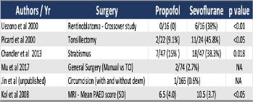

**Reduction in airway reactivity**

* Laryngospasm is one of the most common respiratory adverse events in children
* Comparing to sevoflurane, propofol was shown to be associated with less airway reactivity and laryngospasm
* In APRICOT trial, a large prospective multi-center observational study in Europe, it was revealed that respiratory adverse events were significantly less common in TIVA anaesthesia
* Afterall, apart from oxygen therapy and administration of CPAP, propofol is the first drug of choice to break laryngospasm!

**TIVA is necessary in the following clinical situations:**

* In patient with susceptibility to malignant hyperthermia or there is a strong family history in an untested child
* Outside locations when inhalation agents is not available
* Procedures requiring intra-operative neurophysiological monitoring
* Shared airway in ENT procedures such as endoscopic airway assessment and intervention

**Why should I use TIVA in children?**

* Your paediatric patients will benefit from the advantages of TIVA if you use it in your general practice
* This would also help you prepare and become confident in this technique when it becomes necessary.

**How is propofol pharmacokinetic and pharmadynamics different in children?**

* **Pharmacokinetics**
  + Clearance matures rapidly in the first six months of life.
  + Higher induction and maintenance doses are required due to larger central compartment volume and higher clearance per kg.
  + Clearance is limited by hepatic blood flow and reduced in children with low cardiac output.
* **Pharmacodynamics**
  + Target concentrations are similar to those of adults.
  + Children may have slightly lower sensitivity to propofol.
* **Adverse Effects**
  + Pain on injection is less well tolerated
  + May be reduced by the use of MCT-LCT formulation and lidocaine.
  + May be also be alleviated with administration of remifentanil infusion until child is drowsy
  + Profound hypotension may occur in neonates.

**Practical Approaches for TIVA in Children**

* **Drug Delivery**
  + **Always use one way valve**
  + Uses syringes and extension tubing with luer locks
  + Keep minimum dead space between the three-ways and IV
  + Always use carried fluid for small infants and neonate as the dose at induction is small and infusion rate is low
  + Consider central venous access for major surgery.
  + Use pumps with good alarm which alert high pressure, occlusion, kinking or dislodgement
  + Use TCI pumps whenever possible for accurate drug delivery.
* **TCI Induction**
  + For TCI induction ensure IV is well secured at induction
  + Gentle restrain on limbs over IV at induction (instead of applying tight facemask on patient to cause more stress and anxiety!)
  + When patient becomes drowsy may start to apply facemask for pre-oxygenation
  + Since TCI induction is usually slower and more gentle comparing to IV bolus induction, patient may not tolerate full chin lift and jaw thrust as they lost consciousness. Apply increasing more support as patient becomes deeper
* **Gas induction**
  + TIVA after gas induction is feasible
  + Start at low Cp or Ce target after effective premedication or gas induction
* **Infusion Regimes**
  + TCI pumps are more accurate than manual regimes.
  + Start with a higher target concentration in younger children and infants especially if Cp target is used
  + Titrate slowly of Ce target is used

**Manual infusion regimens**

Children 3 -11 yr with McFarlan regimen

**Loading dose of 2.5mg/kg**

| Time | Dose rate mg/kg/hr |
| --- | --- |
| First 15 min | 15 |
| 15 – 30 min | 13 |
| 30 – 60 min | 11 |
| 60 – 120 min | 10 |
| 120 – 240 min | 9 |

Children < 3 year old - Morse et al 2022

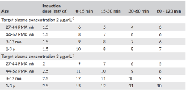

The Obese Child

* Use appropriate size metrics for each drug.
* Eleveld model is a good option
* Consider lower target concentrations.
* Use a processed EEG monitor.

***SIMTIVA.app*** is handy and useful guide to TIVA administration if appropriate TCI models for your patient is not available or if you have to administer TIVA by manual infusion.

Monitoring in Children

* pEEG monitors are useful for assessing depth of anaesthesia but have limitations, particularly in infants.
* Consider raw EEG and spectrogram as guide to depth of anaesthesia young children

Troubleshooting

* Patient is moving a lot during induction despite increasing dose
  + Check the Pump – is it running?
  + Check IV – any leakage or extravasation?
* Patient moves with surgical stimulation
  + Stop surgery
  + Ensure adequate analgesic and anesthesia
  + Check the pump and iv

Propofol Infusion Syndrome

* Rarely reported in children undergoing prolonged anaesthesia
* However it is well documented in critically ill children
* Current guidelines suggest that propofol should not exceed 4mg/kg/hr for a period greater than 48 hours
* Moreover monitor for PRIS is also important in early detection of PRIS
  + Arterial blood gases, serum lactate, creatinine kinase, electrolytes, liver and renal functions
  + EEG changes: Brugada-like pattern as a sign of cardiac electrical instability that predict imminent cardiac death
    - Incomplete RBBB and ST segment elevations in anterior precordial lead

Strategies to prevent propofol infusion syndrome

* Avoid propofol
* Limit the dose by using adjuncts
* Avoid propofol in high risk patients: Critically ill patients, patients on on steroids and inotropes, patients with high catecholamine level, patients with Fatty Acid Oxidative Disorder
* Maintain adequate glucose intake

Specific Metabolic diseases

1. Mitochondrial diseases

* Already reduced ATP production
* Susceptible to developing PRIS

2. Fatty Acid Oxidative Disorder

*Acyl-Co-A Dehydrogenase deficiency*

* Cannot metabolize MCT/LCT
* Predispose to arrhythmias

*Carnitine-acylcarnitine translocase (CACT) deficiency*

* Cannot metabolize LCT
* Predispose to arrhythmias